Introduction to ITWS

Quiz 1: March 1, 2018

There are 5 questions of multiple parts. Point values and suggested times are indicated

Place your name on the top of the document in the header

Enter your answers directly into this document (with the exception of #2)

All answers should be in be in Your Own Words, and use proper grammar

Make sure your answers use an alternative font and/or color

Save the document as *yourname*-quiz1.docx (or doc)

Place all documents including this one in a folder named

ITWSQuiz1-*yourname*-*yourRCSID*

When finished with the quiz, zip your folder and all related files into a file named

ITWSQuiz1-*yourname*-*yourRCSID*.zip

And submit it to LMS

Follow all of these instructions or you will lose points

1. Network protocols, HTML & WWW : (20 points, 10 minutes)  
   1. Explain how the OSI 7-layer model is relevant to me searching the answer this question on Google. (5 points)

The OSI 7 layer model consists of the following layers (bottom to top): Physical, Data Link, Network, Transport, Session, Presentation, and Application. It is relevant to searching this answer on Google because the OSI 7 layer model is a representation of the process of communication between two endpoints in a telecommunication network. For example, a Google search would begin at the 7th (Application) layer. After determining whether or not a communication link can be established, we move to the 6th (Presentation) layer where the OS converts incoming and outgoing data from one format to another (encryption). The 5th (Session) layer sets up, coordinates, and terminates conversations usually executed by TCP and UDP. The transport layer (4th) packetizes the data, the network layer (3rd) handles addressing, the data link layer (2nd) sets up links across the physical network, and finally the physical (1st) layer involves the actual hardware that transmits the data.

* 1. What is a VPN. Why do we need/use it (give an example)? (5 points).  
       
     A VPN is an acronym for Virtual Private Network.  A VPN extends a private network across a public network, and enabled users to send and receive data across shared or public networks as if their computing devices were directly connected to the private network. Since the connection is private, we can act as if we are on a LAN even though we are not physically connected. VPNs are important because they allow for secure and private communication between two users even on public networks.
  2. Explain the difference between a GET and a POST request, and give specific examples of their use? (5 points)  
       
     1. GET request methods requests a resource from the server, and is the most often used method. It is motioned any time we click on a hyperlink on a website or interact with content that is managed by a backend. No content is sent in the request  
       
     2. POST requests are used (typically) to submit forms. The form field values are included as the content of the request (in the message body). This may requires additional headers (to specify how many bytes in the content, what kind of encoding, etc)
  3. What is the difference between an IRI and a URI and describe a URI’s format in detail as covered in class? (5 points)  
       
     A URI is a Uniform Resource Identifier, and it comes in two different forms.   
       
     The first is a URL, or *Uniform Resource Locator*. This specifies WHERE a file is, and has the format: scheme://domain:port/path?query_string  
       
     The second form is a URN, or *Uniform Resource Name*. This specifies WHAT we are referring to, and has the format: urn:*NamespaceIdentifier*:*NamespaceSpecificString*  
       
     While URIs are limited to a subset of the ASCII character set, an IRI may contain characters from the Universal Character Set (Unicode/ISO 10646), including Chinese and Japanese characters.

1. HTML & CSS (40 points, 20 minutes)

Instructions to this question are contained in the HTML file in the zip folder you downloaded from LMS.

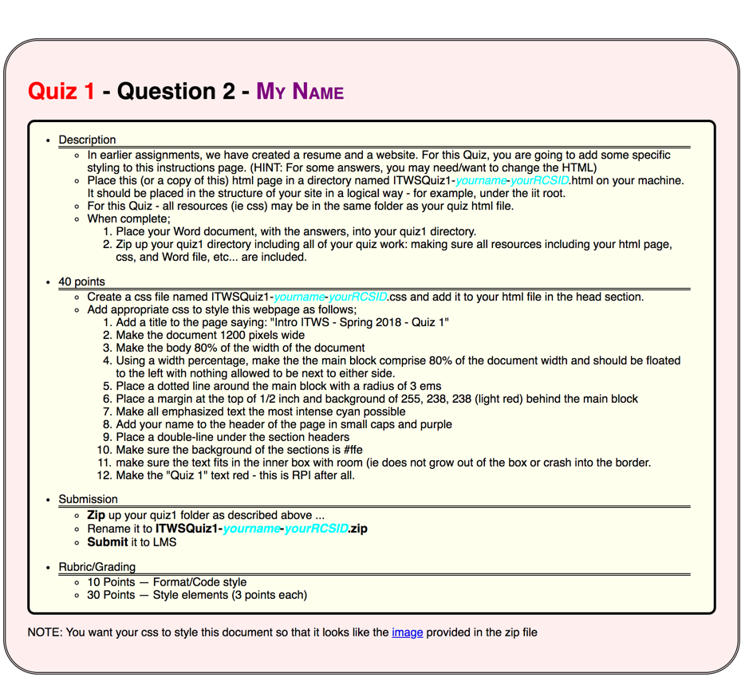

1. Communications and Networks. (20 points, 10 minutes)
   1. What is the Value of a network? What is the cost of a network? How do they relate? (Answer in complete sentences) (10 points)  
        
      Metcalfe's law states that the *value* of a telecommunications network is proportional to the square of the number of connected users of the system ($n^{2}$). In other words, the value increases quadratically/exponentially in terms of the number of users, $n$. However, Metcalfe’s law also states that the *cost* of a network is proportional to the Number of Users. In other words, the cost increases linearly in terms of the number of users, $n$.
   2. As discussed in class: What is Time Division Multiplexing? Why is it useful? (Answer in complete sentences) (10 points)  
        
      Time Division Multiplexing, or TDM, is a way of dividing a communications medium into channels is to allocate each sender a recurring segment of time, namely a "time slot”. For example, the network could take 20 milliseconds out of each second to allow each sender to send messages only within the sender’s own respective time slot.
2. Web Science Guest Lecture (10 points, 10 minutes)
   1. What is Web Architecture? What are 3 related core standards (Answer in complete sentences) (5 points)  
        
      Web architecture is quite simple. It involves a standard system for *identifying* resources, standard formats for *representing* resources, and a standard protocol for *exchanging* said resources. The relevant core standards include URI (URL), HTML, and HTTP.
   2. Name at least three core principles for creating a healthy web. Why is Linking important? (Give an example) (Answer in complete sentences) (5 points)  
        
      The core principles for creating a healthy web are: Using URIs as names for **things**, using HTTP URIs so people can **look up** those names, **returning useful information** when someone looks up that URI, and including links to other URIs so consumers can explore more things. The last principle relates heavily to Linking. Linking is important because without ways to bridge between content, we would not have a network. The network exists solely due to the fact that there are those bridges to take a user from one side of the web to the other instantaneously
3. “Facebook Fake News in the Post-Truth World” Case (10 points, 10 minutes)  
   1. What are network effects? Why are network effects crucial to the success of a social networking platform? (5 points)  
        
      A network effect is the positive effect that an an additional user of a good or service has on the value of that product to others. When a network effect is present, the value of a product or service increases according to the number of others using it. The network effect can create a bandwagon effect as the network becomes more valuable and more people join, resulting in a positive feedback loop. This is crucial to the success of a social network because the more people that join the social network, the more value it has and the more likely people are going to find it. It creates a never ending cycle of growth.
   2. If you were to start a social networking platform tomorrow, what would your plan be for generating revenue? Why? (5 points)  
        
      My main source of revenue would be advertisements, as expected. Advertisements are the most effective way in generating money from free to use services. For example, Snapchat plays a 10 second skippable advertisement in between each user story. YouTube has mid roll ads that function like commercials when watching videos. And Facebook has targeted promotional advertisements that appear in a user’s timeline as he or she is scrolling through the feed.  
        
      However, I would also be open to other models of revenue such as a subscription based model. For a low monthly fee the service would be free of advertisements and it could also possibly grants premium users special features that aren’t normally available to regular users. This model would ensure the social network is generating revenue whether people pay or not. Those who don’t mind the infrequent advertisements or don’t care to pay for premium access features are still generating money so long as they stay on the site. Those who do decide to pay get the luxury of opting out of the cumbersome ads all while being rewarded with features that non paying users don’t get.